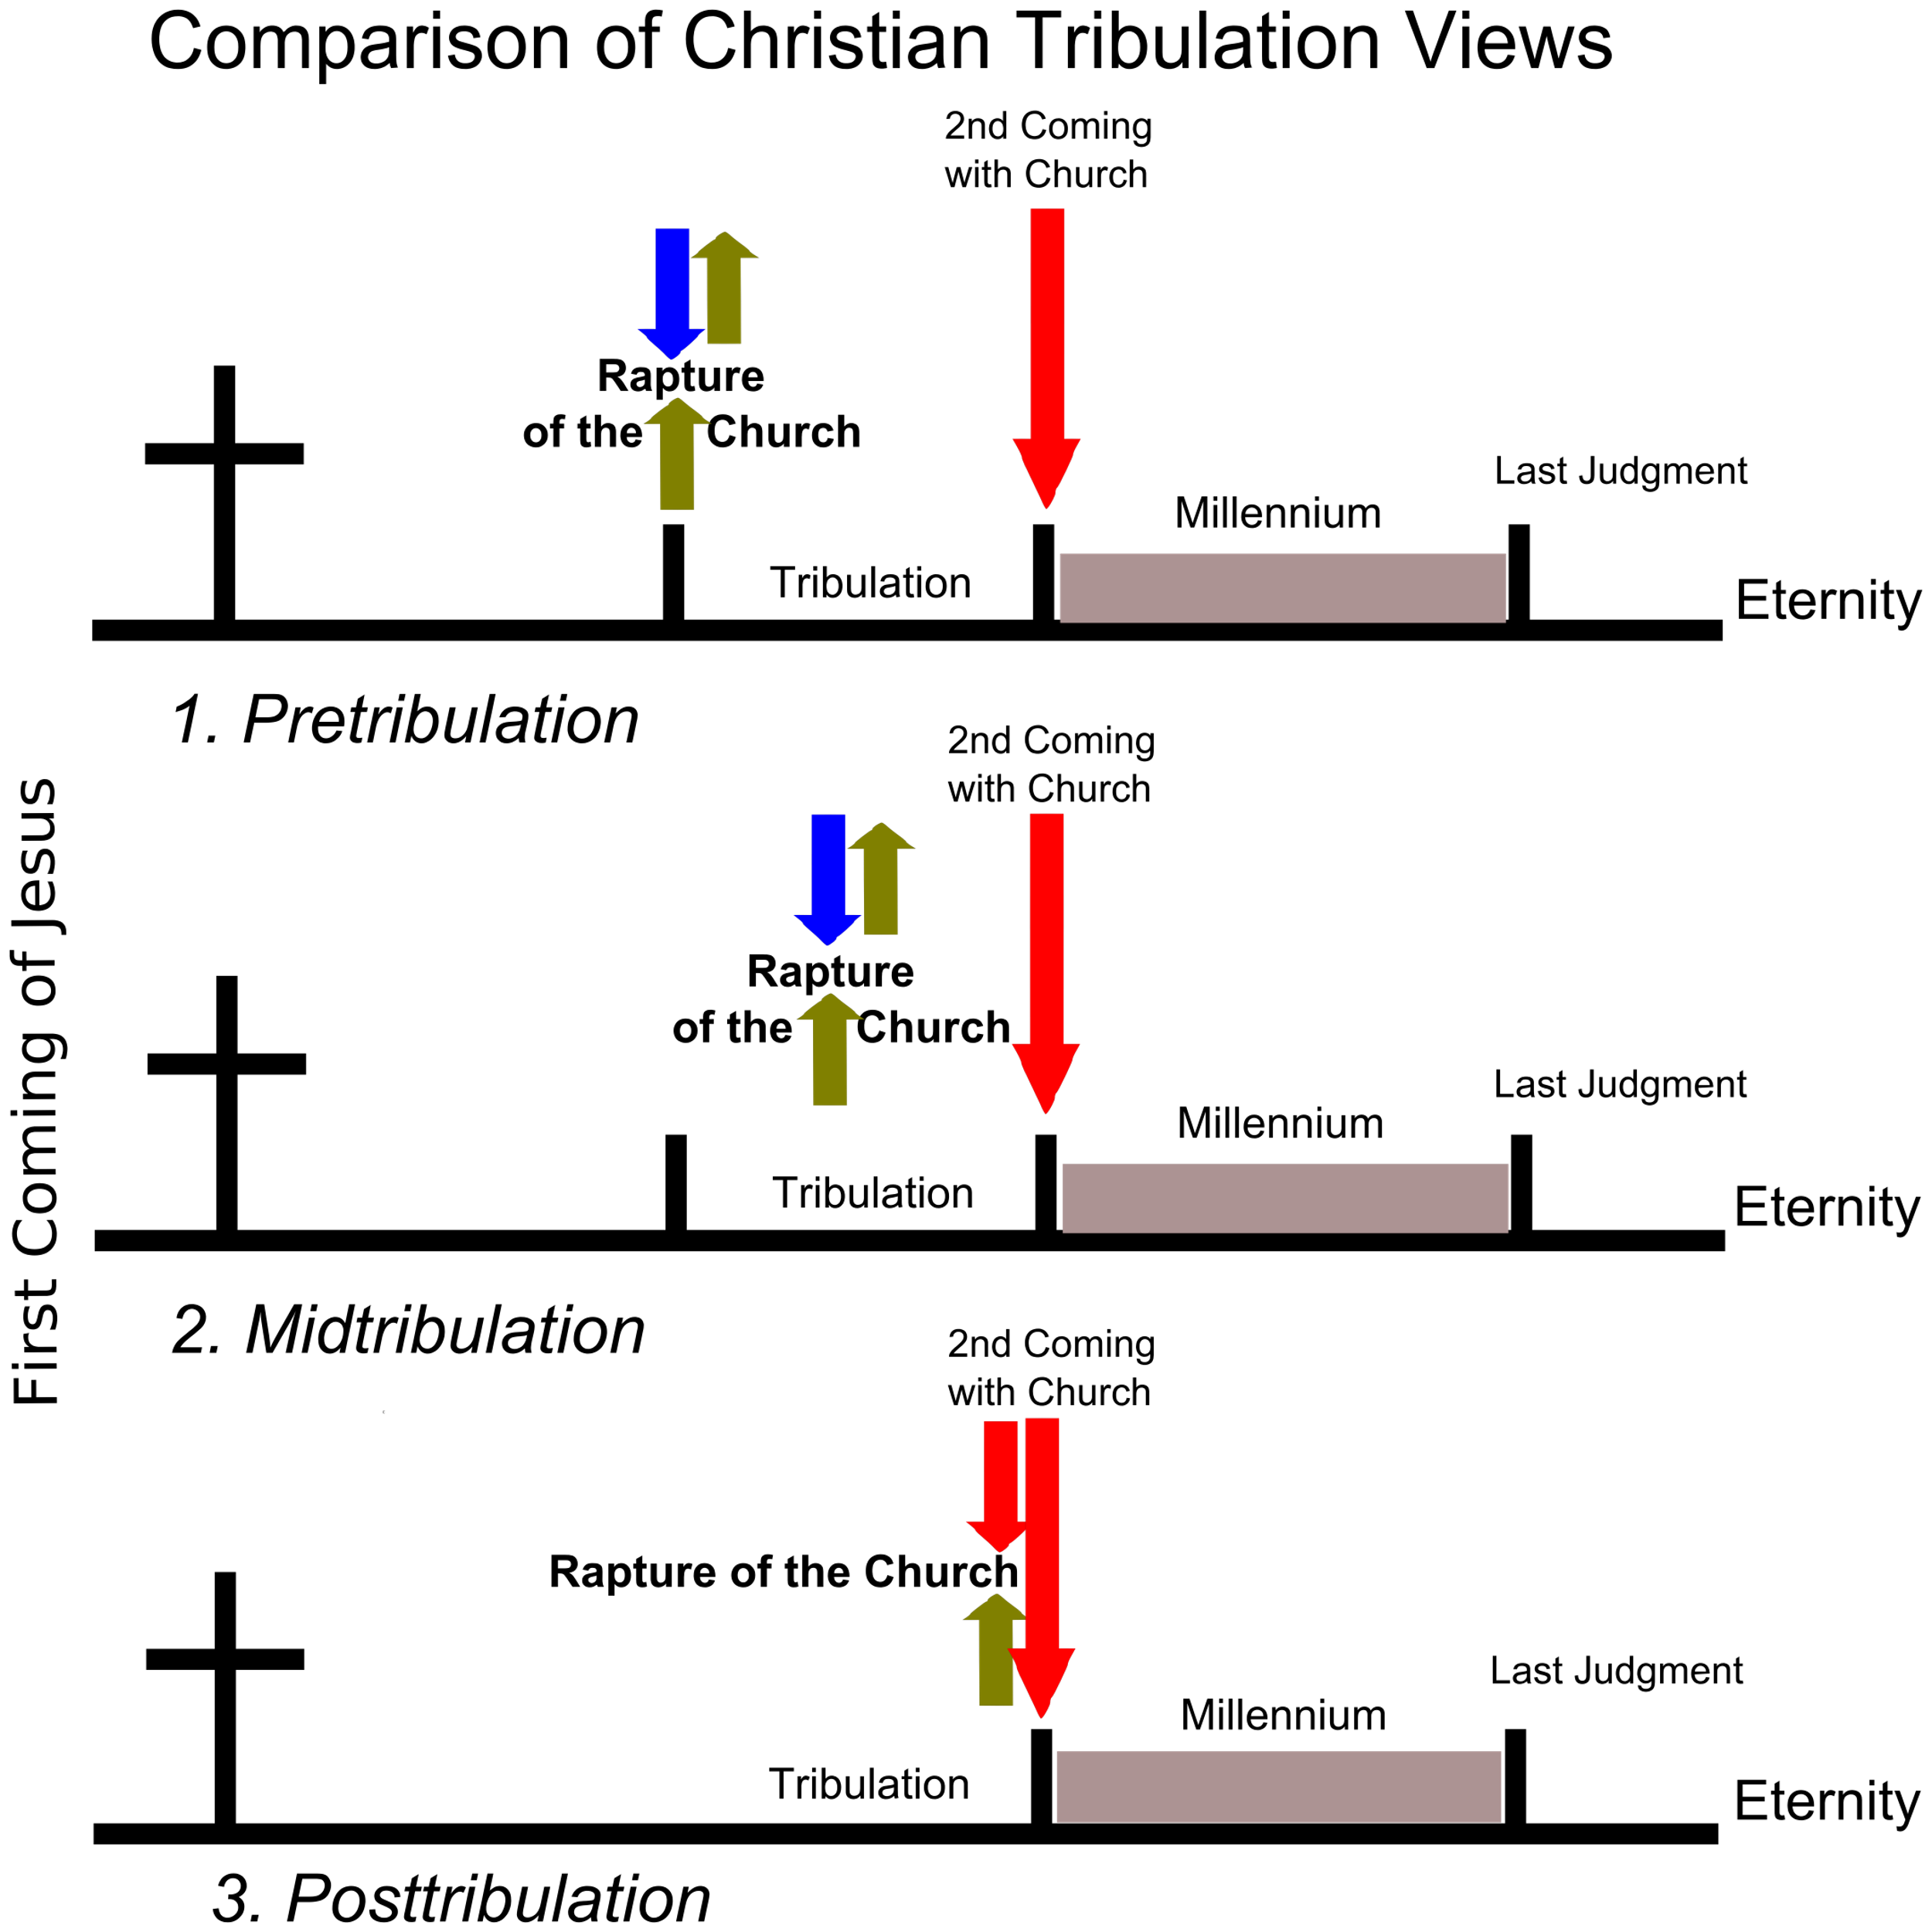

**Anti-Christ:** a man will arise to oppose Christ and His followers more than anyone else in history. Antichrist will seek world domination and will attempt to destroy all followers of Jesus Christ and the nation of Israel.

**Armageddon**: Future, final battle near Jerusalem at end of Tribulation when angel pours out the 6th bowl judgement. [See Rev 16 and 19]

**Millennium**: The Millennium is mentioned six times in Revelation,as a literal, physical 1,000-year reign of Jesus Christ on the earth after His 2nd Coming.

**Cliff Notes Terminology For Biblical End Times**

**Olivet Discourse:** Mark 13; Matthew 24-25; Luke 21

**Eschatology:** Biblical study of Future events relating to Last Days / End Times.

**Daniel’s 70 Weeks:** A prophetic vision from the Angel Gabriel to Daniel. 70 weeks of Israel’s future before Jesus sets up His millennial kingdom. Of the 70 “sevens”, 69 of the weeks have already occurred in history. The 70th week is the Tribulation. There is a “gap” in time from week 69-70 week called, *The Church Age.* See Daniel 9:24-27

**The Church Age:** The Period of time the Church is on the earth beginning in Acts 2 (the birth of church) until the church is Raptured (See 1 Thes. 4).

**Rapture:** A future event when God resurrects all believers who have died, give them glorified bodies, and take them from the earth, along with all living believers, who will also be given glorified bodies at that time.

***15****According to the Lord’s word, we tell you that we who are still alive, who are left until the coming of the Lord, will certainly not precede those who have fallen asleep.****16****For the Lord himself will come down from heaven, with a loud command, with the voice of the archangel and with the trumpet call of God, and the dead in Christ will rise first.****17****After that,* ***we who are still alive and are left will be caught up together with them*** *in the clouds to meet the Lord in the air. And so we will be with the Lord forever.* 1 Thess 4:15-17 [See [Jn 14:1-4](https://biblia.com/bible/esv/John%2014.1-4); [1 Cor 15:51-52](https://biblia.com/bible/esv/1%20Cor%2015.51-52)]

**Tribulation / Day of The Lord:** Daniel’s 70th week, the final 7-year period when God will finish His discipline of Israel and finalize His judgment of the unbelieving world. [Dan 9:24-27](https://biblia.com/bible/esv/Dan%209.24-27) and [Rev 6:1–19:21](https://biblia.com/bible/esv/Rev%206.1%E2%80%9319.21)

**Great Tribulation:** Jesus refers to the 2nd half of the 7-year Tribulation (i.e. 3 ½ years) as more intense, unlike anything in history (Matt 24:21).

**IN LIGHT OF JESUS’ RETURN…**

**Mark Chapter 13**

*As Jesus was leaving the temple, one of his disciples said to him, “Look, Teacher! What massive stones! What magnificent buildings!”* ***2****“Do you see all these great buildings?” replied Jesus. “Not one stone here will be left on another; every one will be thrown down.”* ***3****As Jesus was sitting on the Mount of Olives opposite the temple, Peter, James, John and Andrew asked him privately,****4****“Tell us, when will these things happen? And* ***what will be the sign*** *that they are all about to be fulfilled?”* Mark 13:1-4

* **Be Discerning About the SIGNS: [not ONE Sign but many]**

**__ False “Christ’s”.**

***5****Jesus said to them: “Watch out that no one deceives you.****6****Many will come in my name, claiming,* ***‘I am he,’*** *and will deceive many.*Mark 13:5-6

***21****At that time if anyone says to you, ‘Look, here is the Messiah!’ or, ‘Look, there he is!’ do not believe it.****22****For* ***false messiahs*** *and* ***false prophets****will appear and perform signs and wonders to deceive, if possible, even the elect.****23****So be on your guard; I have told you everything ahead of time.*

Mark 13:21-23

**__ Wars & Rumors of Wars.**

***7****When you hear of* ***wars and rumors of wars****, do not be alarmed.* *Such things must happen, but the end is still to come.****8****Nation will rise against nation, and kingdom against kingdom.* Mark 13:7-8a

*There will be* ***earthquakes*** *in various places, and* ***famines****. These are the beginning of* ***birth pains****.* Mark 13:8b

**__ Persecution**.

***9****“You must be on your guard. You will be handed over to the local councils and flogged in the synagogues. On account of me you will stand before governors and kings as witnesses to them.* Mark 13:9

**__ Widespread Evangelism**.

***10****And the gospel must first be* ***preached to all nations****.* Mark 13:10-11

Mark 5:9-10

­­­­

**__ Familial Betrayal.**

***12****“Brother* ***will betray brother*** *to death, and a father his child.* ***Children will rebel*** *against their parents and have them put to death.* Mark 13:12

**__ Hatred Of Christians.**

***13Everyone will hate you*** *because of me, but the one who stands firm to the end will be saved.* Mark 13:13

**__ An Abomination That Causes Desolation.**

***14****“When you see ‘****the abomination that causes desolation’****standing where itdoes not belong—let the reader understand—then let those who are in Judea flee to the mountains.* Mark 13:14

**__ Cataclysmic Cosmic Disasters.**

***24****“But in those days, following that distress, “‘the sun will be darkened, and the moon will not give its light;* ***25****the stars will fall from the sky, and the heavenly bodies will be shaken.’* Mark 13:24-25

* **… Be Hopeful And PATIENT.**

***26****“At that time people* ***will see*** *the Son of Man coming in clouds with great power and glory.****27****And he will send his angels and gather his elect from the four winds, from the ends of the earth to the ends of the heavens.* Mark 13:26-27

**KEY: We Know Jesus' Return Will By PHYSICAL, Visible And Redemptive.**

* **… Be Watchful And PREPARED.**

***32****“But about that day or hour no one knows, not even the angels in heaven, nor the Son, but only the Father.****33Be on******guard****!* ***Be alert!****You do not know when that time will come.****34****It’s like a man going away: He leaves his house and puts his servants in charge, each with their assigned task, and tells the one at the door to* ***keep watch****.* Mark 13:32-34

***35****“Therefore* ***keep watch*** *because you do not know when the owner of the house will come back—whether in the evening, or at midnight, or when the rooster crows, or at dawn.****36****If he comes suddenly, do not let him find you sleeping.****37****What I say to you, I say to everyone: ‘Watch!’”* Mark 13:35-37